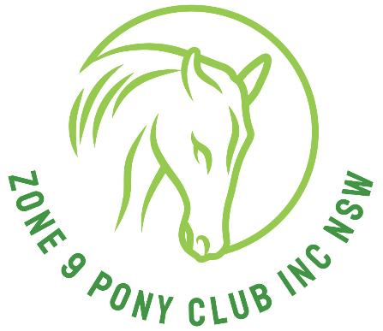
Zone 9 Pony Club Association Inc.
Zone 9 Uniform Steward
c/- Zone 9 Secretary
pcazone9uniforms@gmail.com
Zone 9 Uniform Purchase Form
Name of Rider ___________________________________________
Address ________________________________________________
Phone contact ___________________________________________
Club Name ______________________________________________
Event Attending __________________________________________
Date Required _______________Posting or Pick up _____________
Please list sizes required below –
All uniform are all in Children’s sizing,
Child 10, Child 12, Ladies 8 = Child 14, Ladies 10 = Childs 16 for Polo shirts limited sizes.
Ties are zipper small medium and large. Dress Shirts are Sizes are 6,8,10,12,14,16,18,20,22.
Dress Shirt $35.00 Size___________ Qty_____________
Jumpers $60.00 Size___________ Qty_____________
Tie $20.00 Size___________ Qty_____________
Polo Shirt $30.00 Size___________ Qty_____________
Saddlecloths
Pony $80.00 sizes 55 x 82cm Qty____________
Cob $85.00 sizes 60 x 90cm Qty____________
Full $100.00 sizes 65 x 95cm Qty____________
POSTAGE $ 20.00 approx. Qty ____________
TOTAL PAYABLE $ _
Please complete this form and return to Zone 9 Secretary at the above email address at least 21 days prior to your event to ensure availability.
Payment to be made to
Zone 9 Pony Club Inc
BSB: 062 560 Account number: 2801 6230
Ref : Uniforms with your name and your Club

Zone 9 Uniforms

Re: Zone 9 Uniform: for the State Tetrathlon
- Jumping phase
Eventing body protectors are mandatory
The use of approved Body Protectors. They may be worn over or under Zone 9 Pony Club uniform.
A body protector manufactured after 2009 and labelled as complying with one of the following standards is mandatory effective 1st January 2020. EN13158:2009 level 3 BETA 2009 Level 3 EN13158:2018 level 3 BETA 2018 Level 3.
Helmets: The only acceptable approved equestrian SNELL E2001 helmets for use at Pony Club are those that carry the ASNZS 3838, ARB HS 2012, SNELL E2001, ASTM F1163, PAS 015,EN 1384 (manufactured prior to 31 December 2015) or VG1 (from 1st January 2016) all helmets must show Standard accreditation and be specifically designed for equestrian use.

Riding boots, Zone 9 polo T shirt, PCA beige/fawn Jodphurs, Zone 9 Saddle cloth.
- Shoot phase
Zone 9 polo T shirt ( Bottle Green), PCA beige/fawn trousers or jodphurs, joggers
- Running phase
Black running pants, own joggers,
Bottle Green (single colour) Singlet (must cover all of upper body) from Best & Less
- Swimming phase
Green swimming cap, black or own swimmers.

Vet check and presentation for Tetrathlon uniform TBA
If they ask for full pony club Zone 9 uniform it will be:
Beige/fawn Jodphurs, Zone 9 saddle cloth, riding boots, helmet. Zone 9 brow band.
Midford green long sleeve shirt, bottle green tie, bottle green v neck knitted jumper
(please remember jumpers are not compulsory, wear only according to weather conditions)

Re: Other State events eg: State Gymkhana/Showriding/Dressage/Showjumping/ODE
Uniform as per above for full uniform for vet check and presentation,
unless otherwise stated differently on schedule.

Zone 9 Uniform officer: contact C/-Zone 9 Secretary 0412534160.
Zone 9 Brow bands: Liz Brooks 0431881469

Email: pcazone9uniforms@gmail.com

Team Manager Uniform for Presentation:
Long Sleeve mint green shirt & bottle green tie. With either beige or black Jeans/trousers or skirt.
With closed in shoes.
Team Managers must be recognisable through out the event as a team manager in Zone 9 colours.

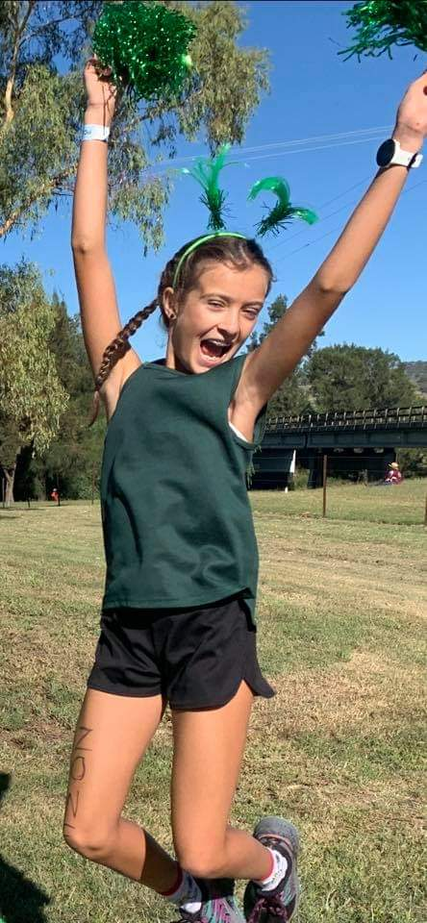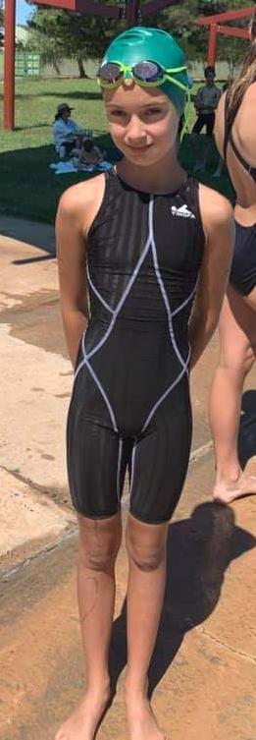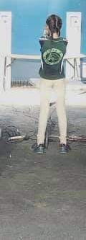

Running Tetrathlon Swimming Tetrathlon Shooting Tetrathlon

Jumping Tetrathlon 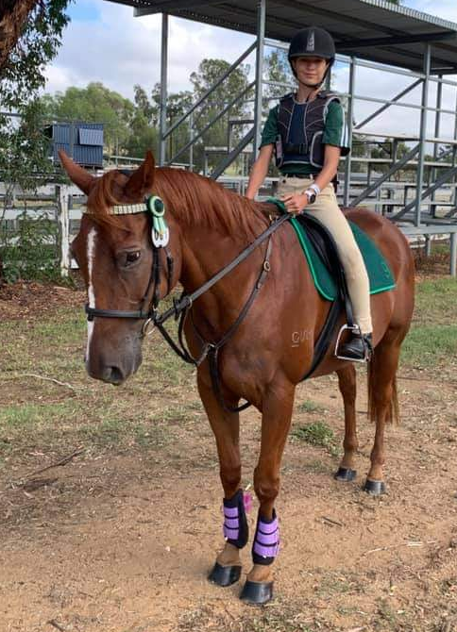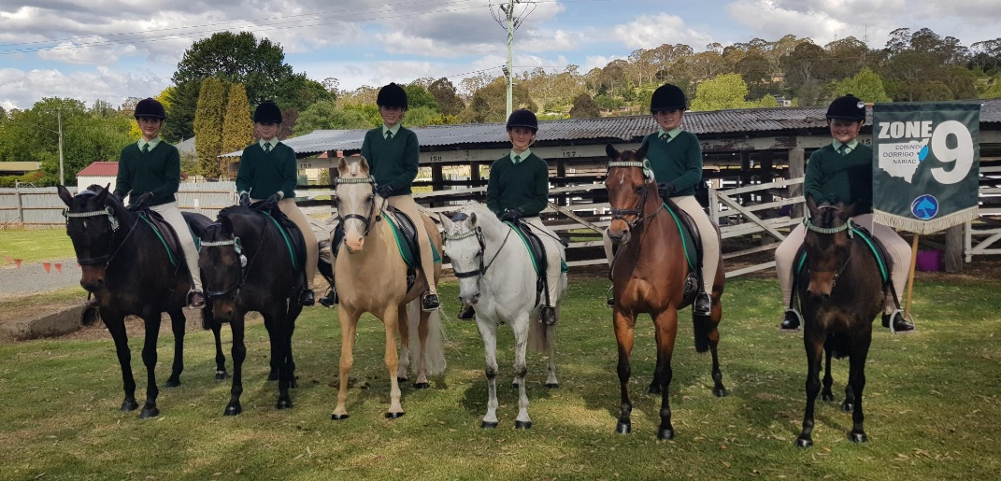

Vet Check and Presentation. Full Zone 9 Uniform.

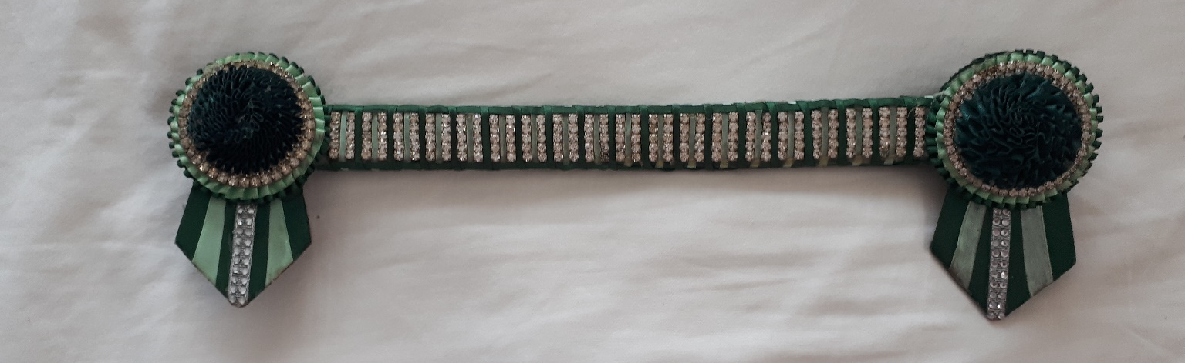
Zone 9 official Browband.

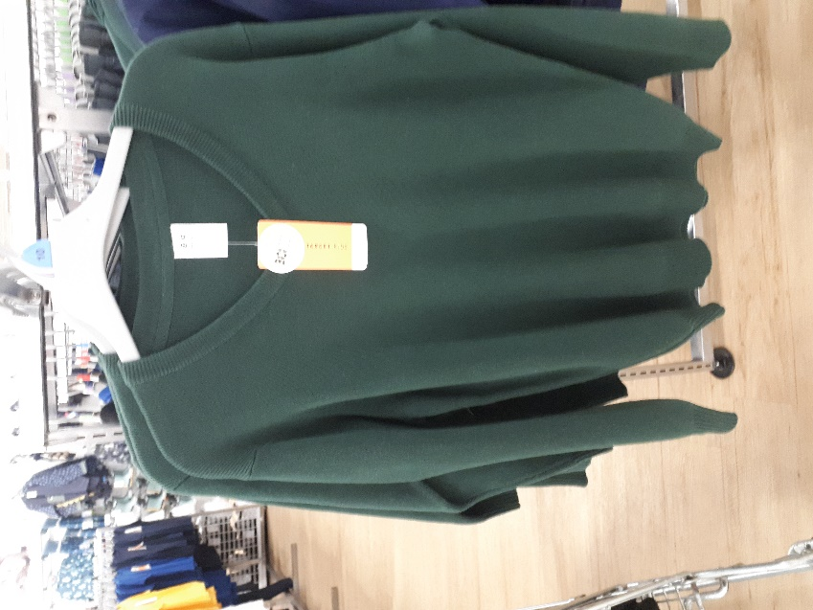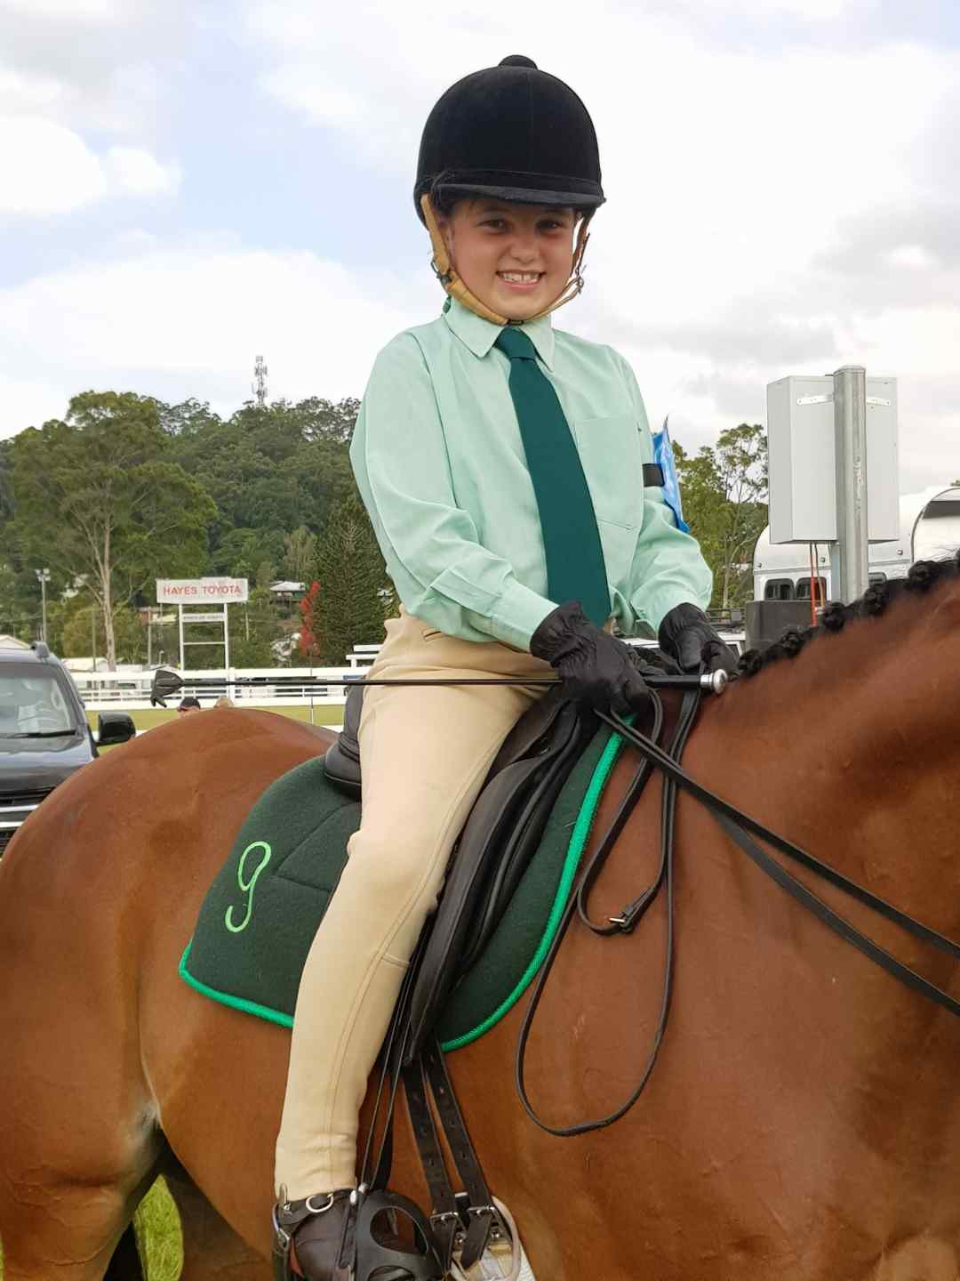
Zone 9 bottle green V neck Jumper Zone 9 Formal Uniform.
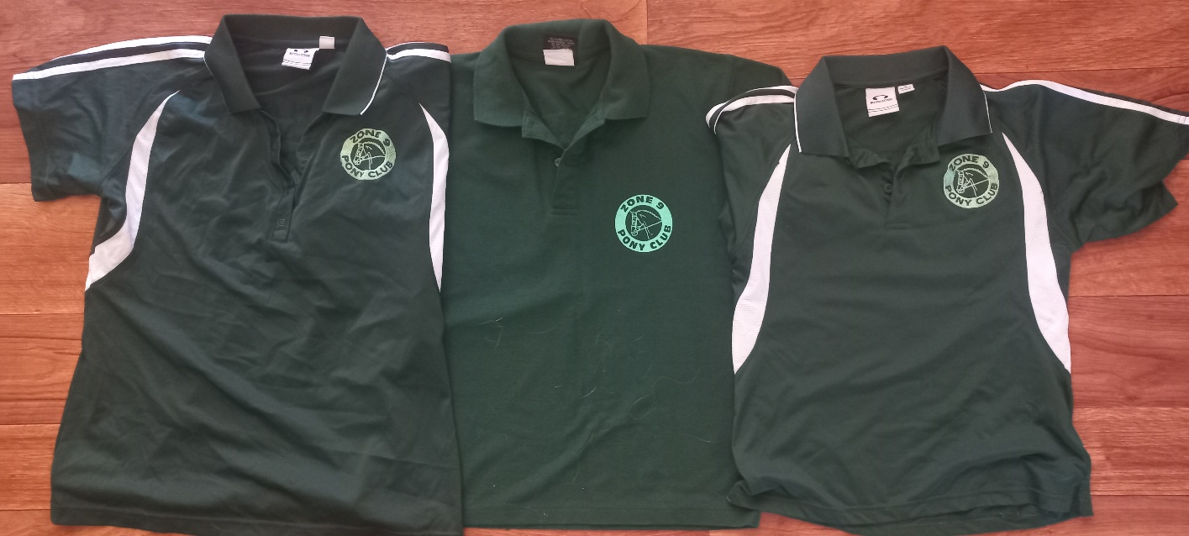
Zone 9 Polo Shirts

