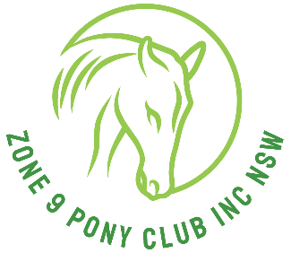
Zone 9 Pony Club Association Inc.

Zone 9 Uniform Steward:
c/- Zone 9 secretary
pcazone9uniforms@gmail.com

Zone 9 Uniform Hire Form

Name of rider |  |  |  |  |  |  |  |  |  | Riders age
Address
Phone |  |  |  |  |  |  |  | Email
Name of Your Club
Event name
Date of Event |  |  |  |  |  | Venue
Delivery & returning method: (at hirer’s expenses)

Hirer’s bank account details for: (Refund of bond)

Account Name:
BSB:
Account No:

This form is to be completed and forwarded to the uniform steward no later than 14 days prior to the event. No Payment No uniform. One person per form.

Bank details are: Zone 9 Pony Club Inc
BSB: 062 560
Account number: 2801 6230
Please quote reference (Uniforms) your name and your club.

A Bond payment is required at hire time to ensure the return/ cleanliness of the uniforms. All hired items must be returned within 1 week of the event (if not your bond will be forfeited) Once inspected by the steward and items are deemed appropriate a refund of the bond will be completed.

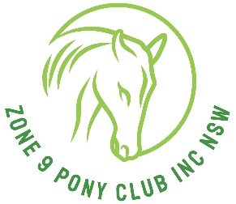

Uniforms for Hire

Item | Size | No Req. | Hire Fee  -Per item
Item | Size | No Req. | Cost per item | Total item cost
Saddlecloth | N/A |  | $15.00
Jumper |  |  | $10.00
Shirt |  |  | $10.00
Tie | N/A |  | $ 5.00
Bond will be refunded once items returned in good order |  |  |  | $ 50.00
Total Hire Fee

Office Use Only
Applicant’s name:
Payment received:
Date items returned:
Bond refund date:

To make sure that all saddle cloths are protected from too much sweat
and horsehair, please make sure a towel or thin saddle cloth
that cannot be seen is underneath the Zone 9 saddle cloth.
This is also a requirement for bond.

Zone 9 Uniforms

Re: Zone 9 Uniform: for the State Tetrathlon
- Jumping phase
Eventing body protectors are mandatory
The use of approved Body Protectors. They may be worn over or under Pony Club uniform. A body protector manufactured after 2009 and labelled as complying with one of the following standards is mandatory effective 1st January 2020. EN13158:2009 level 3 BETA 2009 Level 3 EN13158:2018 level 3 BETA 2018 Level 3.
Helmets: The only acceptable approved equestrian SNELL E2001 helmets for use at Pony Club are those that carry the ASNZS 3838, ARB HS 2012, SNELL E2001, ASTM F1163, PAS 015,EN 1384 (manufactured prior to 31 December 2015) or VG1 (from 1st January 2016) all helmets must show Standard accreditation and be specifically designed for equestrian use.

Riding boots, Zone 9 polo T shirt, PCA beige/fawn Jodphurs, Zone 9 Saddle cloth.
- Shoot phase
Zone 9 polo T shirt ( Bottle Green), PCA beige/fawn trousers or jodphurs, joggers
- Running phase
Black running pants, own joggers,
Bottle Green (single colour) Singlet (must cover all of upper body) from Best & Less
- Swimming phase
Green swimming cap, black or own swimmers.

Vet check and presentation for Tetrathlon uniform TBA
If they ask for full uniform it will be:
Beige/fawn Jodphurs, Zone 9 saddle cloth, riding boots, helmet. Zone 9 brow band.
Midford green long sleeve shirt, bottle green tie, bottle green v neck knitted jumper
(please remember jumpers are not compulsory, wear only according to weather conditions)

Re: Other State events eg: State Gymkhana/Showriding/Dressage/Showjumping/ODE
Uniform as per above for full uniform for vet check and presentation,
unless otherwise stated differently on schedule.

Zone 9 Uniform officer: contact C/-Zone 9 Secretary 0412534160.
Zone 9 Brow bands: Liz Brooks 0431881469

Email: pcazone9uniforms@gmail.com

Team Manager Uniform for Presentation:
Long Sleeve mint green shirt & bottle green tie. With either beige or black Jeans/trousers or skirt.
With closed in shoes.
Team Managers must be recognisable through out the event as a team manager in Zone 9 colours.

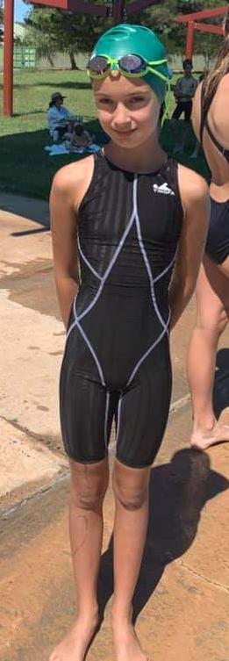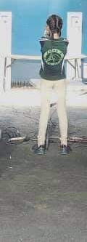

Running Tetrathlon Swimming Tetrathlon Shooting Tetrathlon

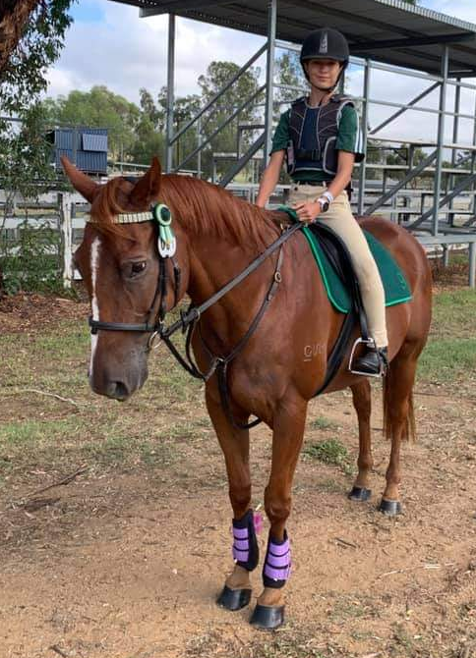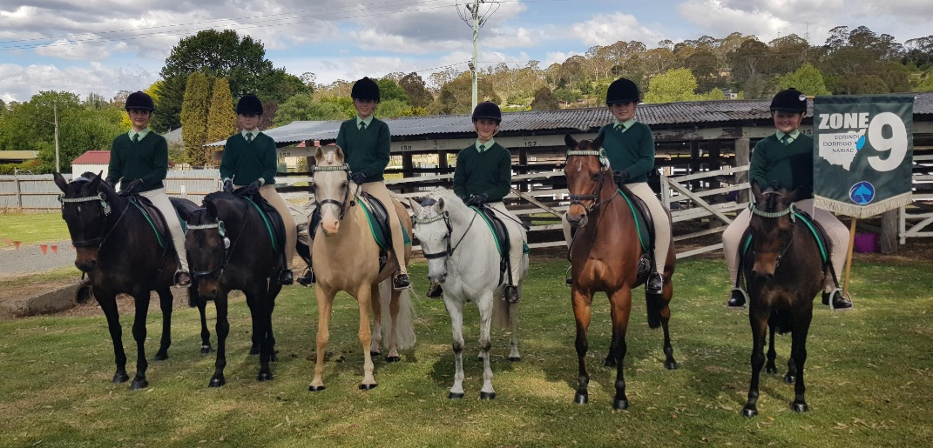

Jumping Tetrathlon Vet Check and Presentation. Full Zone 9 Uniform.

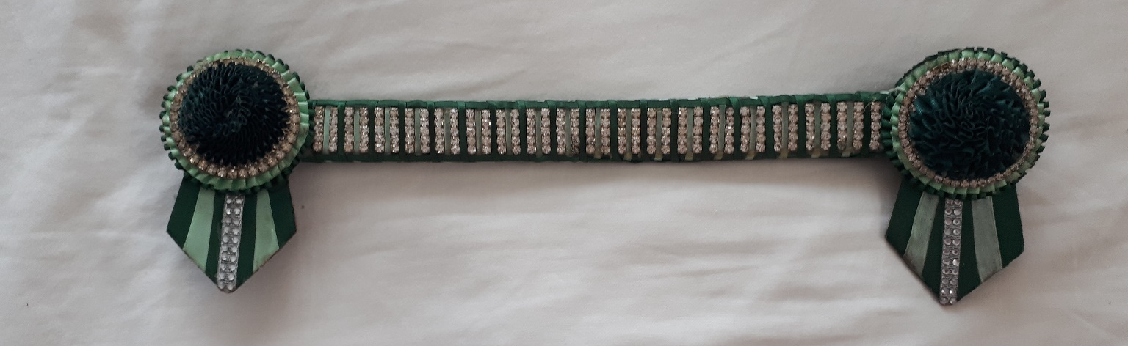
Zone 9 official Browband.

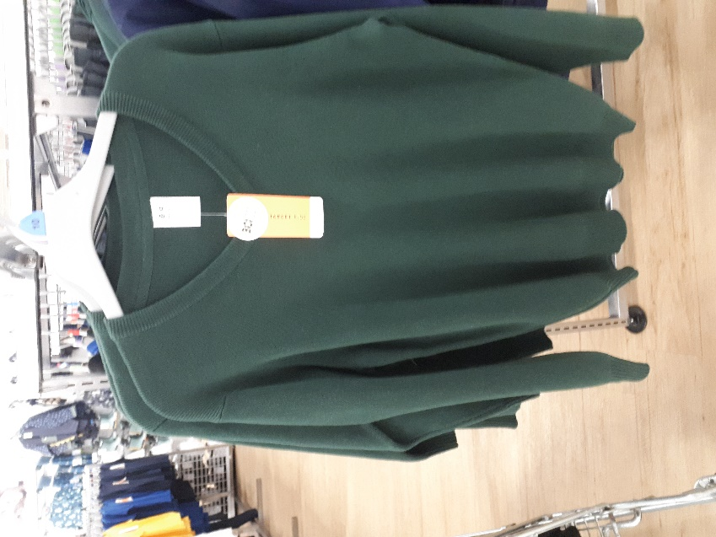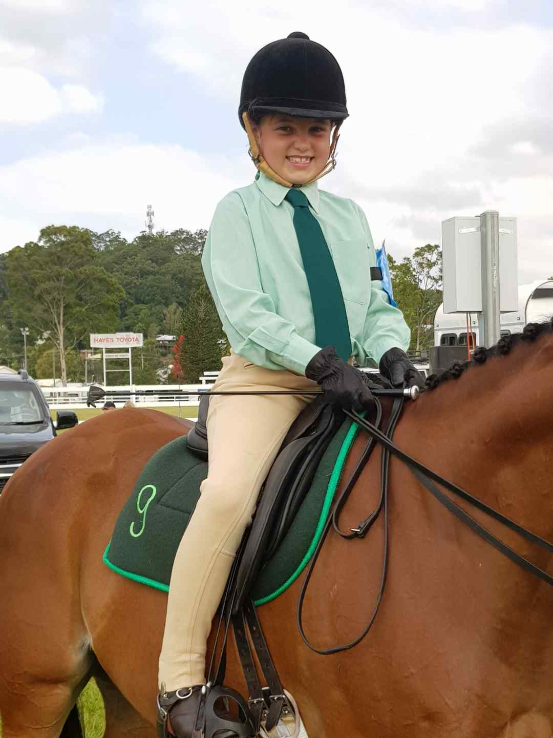
Zone 9 bottle green V neck Jumper Zone 9 Formal Uniform.

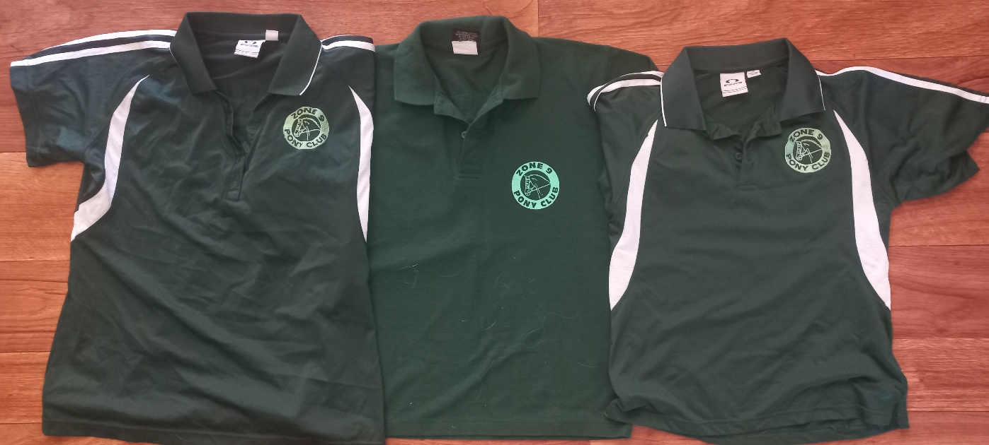
Zone 9 Polo Shirts

