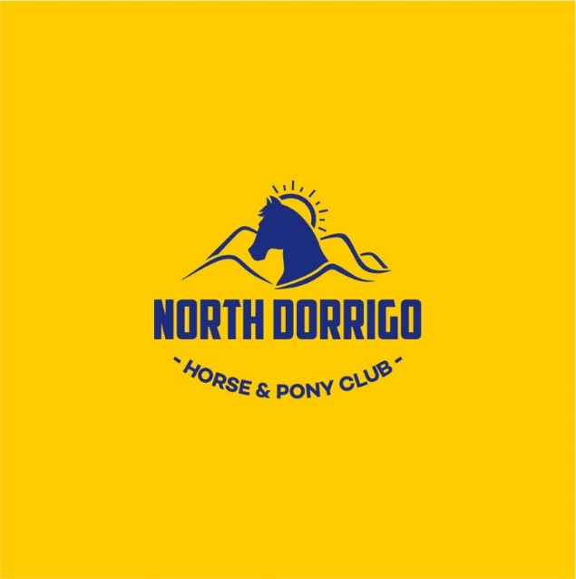
North Dorrigo Horse & Pony Club 2018
Dorrigo Showground
Commencing Friday 9th – Sunday 11th February 2018
Entries are via Nominate & close Sunday 31st January 2018
Entry: Camping $25 p/night Stables $15 p/night + $20 stable levy
Team Penning - $30 p/entry(team) $10 p/rider
Campdraft - $30 p/entry (2 rounds)
Sporting - $26 p/entry
Gymkhana $20p/entry or $50 for family of 3+

FRIDAY 9th February TEAM PENNING – Juniors 10 & Under 17, Associates.
Commencing at approximately 4.30pm on Friday 9th February 2018, numbers permitting

Saturday 10th February CAMP DRAFT – 10 & Under 13, 13 & Under 15, 15 & under 17, Associates.
Commencing at approximately 7.30am, 2 rounds per entry

SPORTING – U7, U9, U11, U13, U15, U17 and Associate.
Qualifier Events Commencing after the campdraft Saturday approximately 11am (numbers permitting)
1. Flag Race 5. Diamond Flag
2. Bending Race 6. Three Mug Race
3. Barrel Race 7. Sporting Figure of Eight
4. Bonfield Bounce Bend

The “DRIFT MEMORIAL” Trophy to be presented to the top team of four riders from the same club for Sporting & Campdrafting. Juniors and Associates are eligible.
The competition will be conducted in accordance with the rules of the NSW Pony Club Association as set out in the “Blue Book” and as advised in Council Minutes to date. Each competitor may enter for both Sporting and Campdrafting on a different horse. Each horse may be entered in one age group only. The horse/ pony must belong to a member of the Club to which the member belongs.

Secretaries, please advise participants: The competition will be conducted in accordance with the Blue Book. RIDERS WHO ARE GIVEN ANY OUTSIDE ASSISTANCE/ INSTRUCTION DURING THE CAMPDRAFTING RISK DISQUALIFICATION.
UNIFORM- Riders are permitted to wear Club Polo Shirts for Sporting only. Long sleeve shirt and tie must be worn for Campdrafting & Team Penning. Moleskins, Roper & Dogger Boots permitted for both events. Riding trousers must not be worn with long boots. Full Pony Club uniform is to be worn i.e. shirt and tie and either fawn or oatmeal jodhpurs. Fawn, bone or oatmeal coloured riding trousers are acceptable. Riding Trousers must be designed specifically for riding or labelled stockman cut, moleskin or similar appellation, the top of which shall be at the rider’s waist and the length of which shall be such that when mounted the top of the rider’s boot shall be covered. Riding trousers may not be worn with long boots.

A Mounted Presentation will be held after “Each Discipline” time permitting. Riders to be in Full Pony Club Uniform. Trophies/Awards will be presented to the competitors mounted.
Neither the organising committee, the Zone 9 Pony Club Association, nor the owners of the property on which the fixture is held, accept any liability for any accident, damage, injury or illness to horse, owner/s, riders, ground spectators or any other person whatsoever.
As this is a qualifying event, please list a worker, & select a discipline who can help to make this event successful! Place their name on the Nominate entry. All Riders are to Nominate a Worker, this includes Associate Riders.

GYMKHANA – Sunday 11th February Gear Check: 7.30am Start: 8:00am
RING 1 | RING 2 | RING 3
Hack Classes
Pony Hack Under 13hh | Galloway Hack 14hh n/e 14.2hh | Hack 15hh n/e 15.2hh
Pony Hack Under 13hh n/e 13.2 | Galloway Hack 14.2hh n/e 15hh | Hack 15.2hh
Pony Hack Under 13.2 n/e 14hh | Beginner Hack | LED Line Rider Hack
Pleasure Hack Classes
Pleasure Hack 15hh n/e 15.2hh | Pleasure Hack Under 13hh | Pleasure Hack Lead Line
Pleasure Hack 15.2hh & over | Please Hack 13hh n/e 13.2hh | Pleasure Hack 14.2hh n/e 15hh
Pleasure Hack Beginner | Pleasure Hack 13.2 n/e 14hh | Pleasure Hack 14hh n/e 14.2hh
Rider Classes
 | Boy/Girl Rider Under 7 | Boy/Girl Beginner Rider
Boy/Girl Rider Under 14 | Boy/Girl Rider Under 9 | Boy/Girl LED Line Rider Pony
Boy/Girl Rider Under 15 | Boy/Girl Rider Under 11 | Boy/Girl Associate Rider
Boy/Girl Rider Under 16 | Boy/Girl Rider Under 13 | Chp & Res Associate Rider
Chp & Res Senior Rider | Chp & Res Sub Junior Rider | Chp & Res Junior Rider
Pairs
Pair of Riders 9 & Under 13 | Pair of Riders Under 9 | Pair of Riders 13 & Under 17
Pair of Associate Riders | Pair of Lead Liners | Pair of Beginner Riders
Team of 4 riders Under 13 | Team of 4 rider 13 & Under 17 | Team of 4 Associate Riders
MARCH PAST WILL BE RUN AFTER THE RIDING CLASSES
NB.. AGES HAVE BEEN COMBINED IN SOME AGE GROUPS DUE TO SMALL NUMBERS HISTORICALLY, IF THERE IS LESS THAN 4 RIDERS IN AN AGE GROUP, AGE GROUPS WILL BE COMBINED OR ALTERED AS NEEDED
Sporting
- Barrells 2. Three Mug Race 3. Diamond Flag 4. Figure of Eight (non pointscore)
Show Jumping TWO Phase
Two Phase (Art. 274.5.2) – A,B,C,D & E Grades
Riders who go clear and under time allowed in the first phase go straight on to the second phase. The finishing line for the
first phase is the starting line for the second phase, and there will be an increase in height in the second phase.
Places awarded according to penalties and time in the second phase.
Rules & Requirements
- All persons entering grounds do so at own risk
- North Dorrigo Horse & Pony Club reserve the right to change the ring & program order as numbers dictate
- All competitors MUST be a member of a Pony Club affiliated with the PCA of NSW. Full pony club uniform must be worn including approved boots & helmets SNELL E2001, PAS015, ARB HS 2012, AD/NZ 3838, ASTM F1163 OR EN1384/VG1 with BSI Kitemark
- LED line riders must stay on the lead all day. NO EXCEPTIONS
- Beginners class is for beginners of any age- that can only walk /trot (if your child can canter they cannot compete in this class)
- JUDGES DECISION IS FINAL IN ALL EVENTS
- One horse one rider applies – must be owned by a member of the competitor’s club, or have a PCA lease.
- Ribbons to 6th place. (judge’s decision is final)
- Entry in events deemed to be acceptance of these conditions.
- Please notify secretary if eliminating from event.
- STABLES MUST BE CLEANED BEFORE LEAVING THE GROUNDS. UNCLEAN STABLES WILL INCUR A FINE TO RIDERS CLUB
- STRICTLY NO DOGS
- HORSES must not be left unattended at floats (If not been ridden stables & yards are provided)
- Pleasure Hack (also known as Pleasure Horse)
The horse must be ridden in a plain bridle with a snaffle bit. The rider must not wear spurs or carry a whip and the reins are held in one hand only. Emphasis should be placed on temperament, obedience, conformation and comfortable riding qualities. The winner of a Pleasure Hack or Pleasure Horse class is not eligible to compete in championship classes.
North Dorrigo Horse & Pony Club will be using NOMINATE for this event,
please log on https://www.nominate.com.au/equestdn/Nominate.aspx & complete
entry online.
Email Northdorrigohorse&ponyclub@gmail.com or contact OJ Fahey 0427643996 or Kylie Raymond 0428552098

