 OXLEY PONY CLUB RIBBON & TROPHY DAY 2016 
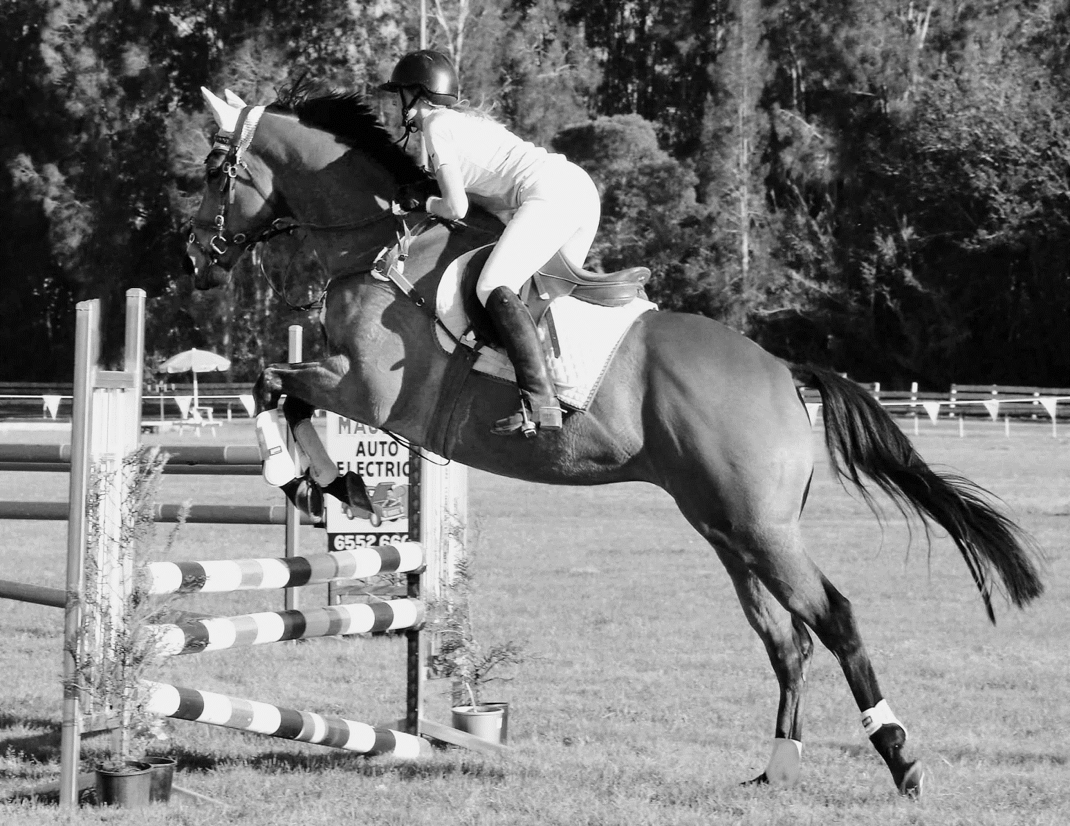
14th August 2016
TAREE SHOW GROUNDS at 8am Gear Check - 8 .30 Start
Enquiries to Lorraine Fitzgerald 0427827933
“ SPECTATORS VIEW FROM OUTSIDE THE ARENA & AWAY FROM THE MARSHALL AREA ”
Entry Fee $25 per rider or $60 a family of three riders or more.
Includes: $5 Showground levy per horse - If you use a stable cost will be $11.00 the day
BOYS AND GIRLS COMBINED ALL DAY
“ Riders From Oxley Island Pony Club to be judged at Gear checking ”.
At 8.00am for best presented/Sash.
Hack Class
Ring 1. Ring 2. Ring 3.
Pony Hack under 14hh Galloway 14hh to 15hh Hack 15hh and over
If sufficent numbers heights will be split further
CHAMPION & RESERVE CHAMPION HACK SASH’S
Hacks are not included in the point score – Leds/beginners are not eligible for Hack classes
Riding Class
Ring 1. Ring 2. Ring 3.
Led Class 7 & U9 13 & U15
Beginner Class (No Canter) 9 & U11 15 & U17
Under 7 11 & U13 Associates – all
CHAMPION & RESERVE CHAMPION SASH’S FOR
JUNIOR – (U7, 7 & U9, 9 & U11) / SENIOR – (11 & U13, 13 & U15, 15 & U17) & ASSOCIATES
Bareback Rider Class
all age group as per riding classes – optional on riding ability
Led and Beginners not eligible for this class.
Pairs
Ring 1. Ring 2. Ring 3.
Led U7 & U9 13 & U17
Beginner 9 & U13 Associates

SPORTING EVENTS
Bending Barrels Scudda Hoe Key hole bounce
JUMPING AM3 – ALL GRADES – U17’S & ASS
E – D Grade Optimun Time
Terms and Condition:
Gear to be done by Oxley Island Pony Club From 8 to 8.30am.
One Horse per rider.
Led riders must be led by affiliated member over 17yrs.
Organisers have the right to merge or separate age groups according to numbers.
Jumping Cards must be produced at time of entry.
All riders must be Financial Members of Pony Club.
All riders compete at their own risk.
Led riders and Beginer Classes are Non – Competative – Not eligable for point scores.
Beginers classes are for riders that are not yet confident in competing in their age groups or for young riders that would like to try competing off the lead. The rules for the beginners class are that the riders do all the events that they would do if they were in an age group. This group is a Walk trot group only. If the rider can canter confidently then they should be able to compete in their usual group. If by chance a rider in the beginner class should break into a canter they will have to turn in a circle then proceed with the event in trot.
We hope you have a great day and have a safe trip home.
SPONSORS - WE THANK YOU
Major Sponsor – For all trophies
Manning Valley Livestock and Property Agents
Other Sponsors – Norco, Taree Produce, Watermans Steak Bistro
Macawsome Avairies, Pennington Family, Double C Saddlery, Bellewood Saddlery Brendon Barnes Farrier, Old Bar Lions Club.



