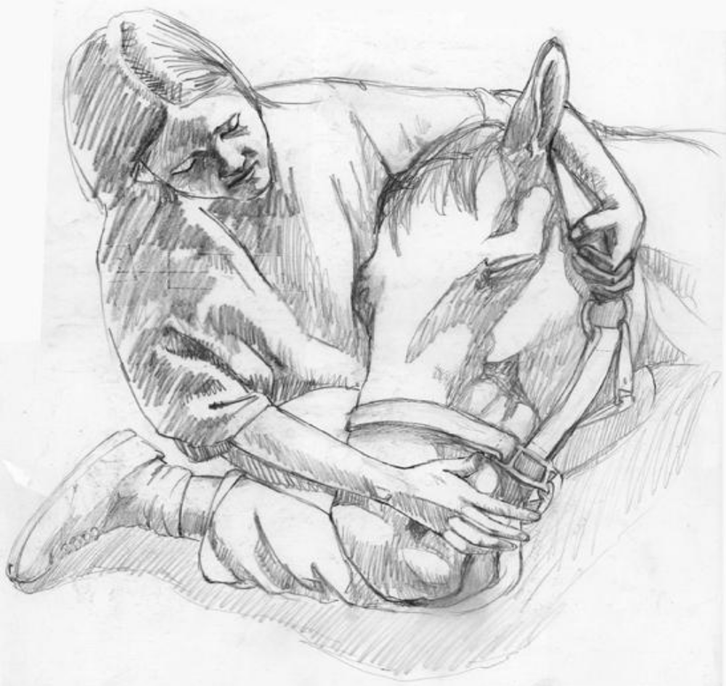

NORTH DORRIGO HORSE AND PONY CLUB ANNUAL CAMP 2014
Sunday 21ST – Friday (Gymkhana) 26TH September
Applications close 5th September
To help out with catering, ordering and organisation it is essential that all forms are completed and returned by the due date.
If there are extra questions you have or there is anything you wish to discuss please contact:
President - Arnold Duckett: 66575241
Secretary and chief instructor - Alisha Fenton: 66572318 or 0427700778
Treasurer - Louise Macrae: 66572682
All children must be in camp by 12:30 on the 21st of September.
This is to allow registration, stabling and scanning to be done. As well as dormitories to be set up. Lunch will not be supplied for Sunday.
PLEASE VISIT THE SECRETARY OFFICE ON ARRIVAL TO REGISTER. AND PLEASE SEND IN A HENDRA VACCINATION CERTIFICATE WITH YOUR NOMINATION FORMS.
TROOP GROUPS AND STABLES WILL ALSO BE ALLOCATED AT THIS TIME & MAY BE REVIEWED DURING THE AFTERNOON.
PARENT MEETING
A Meeting will be held on Sunday 23rd September to explain the happenings for the week
at 2.00 pm
Please ensure you make time to attend so you know what’s going on.
RIDERS WILL ASSEMMBLE, UNMOUNTED OUTSIDE THE
MAIN ARENA AT 2:30pm READY FOR GEAR CHECK & INSTRUCTION.
Each beginner rider must have parent/carer available with them until
Assessed by chief instructor.

GENERAL CAMP ORGANISATION
- Sunday afternoon through to Wednesday afternoon general camp activities.
- Thursday morning is jumping competition.
- Thursday afternoon clean up and preparation for Friday.
- Friday is the camp gymkhana and the last day of camp.
- This is the general overview and is subject to change.

TROOPS DURING CAMP ARE BASED ON SKILL & EXPERIENCE- The instructors will recommend changes as required.
Instructors, we would like you to let us know if you have a preferred area of expertise so that our chief instructor can place you accordingly. You may add this to the back of this form.
PLEASE remember that Pony Club helmets must be worn at all time while around horses they must be AS/NZS 3838, ASTM F1163, EN 1384.
Horses cannot be changed during camp unless being approved by the chief instructor.

WHAT TO BRING
Draw string bag with utensils e.g.: dinner plates, breakfast and dessert bowl, mug, and cutlery.
Bedding
All bedding (bed/stretcher, mattress, sheets, blankets, pillows etc.) and sleeping attire
Clothing
Bring well-worn jeans and jodhpurs for riding during the week with long sleeved shirts with collars for protection. Approved helmet, smooth soled riding boots for riding and sensible shoes for afterwards. Clothing to wear in the afternoon and at night remembering it can get very cool.
Bath towel and toiletries. Sunscreen, hat, wet weather gear, shoe cleaning gear.
Gymkhana Day white long sleeve shirt, navy blue tie & gold/ yellow jumper, cream jodhpurs , royal blue & gold saddlecloth
HORSE NEEDS
Saddle-Well fitting, girth with surcingle OR 2 buckle girth
Bridle-Clean, good stitching and soft reins.
Water Bucket-Approx. 20L minimum
Feed Bin-No hard unfixed containers or bins with sharp edges
Rake/shovel and wheel barrow-For cleaning out stables.
Grooming Kit-Brushes, hoof pick etc. in a suitable bag.
CAMP PERSONNEL
PRESIDENT: Is in charge of the whole turnout and is the ultimate umpire in case of disputes.
CHIEF INSTRUCTOR: Allocate troops, organize riding activities for the week and assign instructors to troops for those activities. Also the person to see if you have any enquiries or issues relating to your child while on their horse.
INSTRUCTORS: Have the care and responsibility of children while mounted or with their horses.
SECRETARY: Handles the paperwork and fields a multitude of questions throughout the week.
TREASURER: In charge of all money matters.
CAMP COMMANDANT: All children are under the care of this person while off their horses anyone wishing to take their child off grounds MUST get permission from this person or record activity in camp book in kitchen.
CAMP PARENT: Sleeps in with girls and looks after the children’s wants and needs through the night.
NOTE: The camp parent will not be able to oversee or provide medications unless supplied by parents or guardians. All medications, including paracetamol, cough mixtures, spare asthma sprays etc. that require supervision should be handed to the camp matron on Sunday in a labelled bag or container with full instructions.
CAMP COOK: Slaves over a hot stove all week to feed the hungry hordes.
KITCHEN COORDINATOR: Responsible for the smooth running of the kitchen.
PARENTS AND HELPERS: The fundamental work force and back bone of any Pony Camp.
PLEASE HELP SUPPORT ALL THESE HARD WORKING PEOPLE DURING THE WEEK BY DOING YOUR SHARE AND VOLUNTEERING WHERE EVER NEEDED.
GENERAL CLUB INFO
1. Membership of North Dorrigo Pony Club is yearly from the 1st January to 31st December.
2. All families joining north Dorrigo Pony Club must fill out an Application form. At least one parent of every family must be a member. Parents must be a riding member if they intend to ride during any pony club event. Parents are only to ride at pony club events after invitation by the Senior Instructor and are not permitted to ride children’s horses at any time during a club event.
3. Volunteers run Pony Club and Pony Camp. Please do your share. We expect all parents to take an active role in the annual camp.
4. As per PCA NSW Guidelines in the event of an accident or emergency, first aid will be administered and if required an ambulance will be called.
5. Conduct of riders and instructors, pony club is a youth organization therefore polices of NO Alcohol, NO smoking, NO swearing applies while attending to children.
This is just a brief outline of North Dorrigo Pony Club. Don’t hesitate to talk to executive members of the Club for more information.
INFORMATION AND RULES
FOR CAMP PARTICIPANTS
1. All Pony Club Association of NSW rules apply AT ALL TIMES.
2. Membership must be paid before a child rides at any pony club event
3. Riders are expected to be polite and attentive during instruction, to enjoy the fellowship with other members and to conduct themselves appropriately at all times.
4. During camp all children are under the direct control of an instructor whilst with their horses. Please do not interfere while your child is under instruction if you have a concern please do not intervene without first speaking with the chief instructor. Parents are not to disrupt the lesson in progress.
5. Each beginner rider must have a parent /carer with them until the chief instructor or their delegate has assessed them to ride independently this will be done on a daily basis
6. For the duration of camp while your child is not on their horse, they are under the direct supervision and control of the Camp Commandant and you must speak to this person about any problems you have with your child. Camp official’s decisions shall be final.
7. No rider is permitted to ride another person’s horse. If there is a horse welfare issue, please seek the advice of the chief instructor.
8. Campers will not be permitted to leave the camp unless permission is granted by the commandant.
9. All children 9 years and over are required to camp in, exceptions are made in the case of emergency or under doctors’ orders
10. Campers are expected to remain in their bed in the dormitory after lights out.
11. Dormitories are out of bounds to all non-campers. There are to be no females in male dormitories and vice versa at any time.
12. Campers will not be permitted to drink alcohol or smoke or drive cars during the camp.
13. Mobile phones cause a major distraction during instruction therefore the use of mobile phones will be restricted to after 5.30PM-8.30PM each evening. It would be preferred if mobile phones, iPhone’s, iPod’s etc. were not brought to camp at all for safety and security reasons.
14. NO dogs are allowed on the grounds
15. No member shall act in an unsportsmanlike manner. Parents are urged to promote good sportsmanship.
16. Inappropriate or bad language will not be tolerated.
17. No vehicles to be parked in horse traffic areas such as the top stable.
18. Any unused horses not on the camp form as an extra horse are to be stabled away from other horses and the owner is responsible for feeding them.
CAMP IS MEANT TO BE A FUN TIME FOR THE CHILDREN LETS ALL PITCH IN AND HELP TO MAKE IT ENJOYABLE FOR THEM AND ALL INVOLVED.

UNMOUNTED……………
Horses are easily spooked and everyone who comes to Pony Club needs to be sensible around horses. Small children should be SUPERVISED at all times and are NOT to sit/climb on any of the railings / stables or jumping equipment.
CHILDREN SHOULD NOT be in the stable area without a helmet and adult supervision at any time.
Children should not be over at the stables at night, this is a safety issue.
MOUNTED………………
Please arrive on time. Late arrivals are disruptive and may result in being left out of a session.
Be considerate of each other and especially of less experienced and younger riders.
Walk at all times unless specifically advised by an instructor.
Always use manners and thank instructors for their time.
Do not leave a session without the permission from the instructor
You must only ride where and when advised NO riding around the clubhouse or dorm areas. Children should be keen and ready to have fun they must be co-operative and ready to listen and learn. Parents please remember that pony club is for children to interact and enjoy themselves.
ROSTERS
Each family is required to work at least one full day during Camp, either by working several shifts during the week or working one whole day. We realise everyone is busy but many hands make light work. The main jobs that require parent assistance are in the kitchen. Guys don’t be afraid of dishpan hands!! Palmolive does wonders on the hands while you do dishes!! Other areas that are in need of your help include shower supervision for both boys and girls, assistance on the grounds to prepare for daily instruction and workers to get ready for major camp events such as Gymkhana day.
PLEASE COMPLETE THE DUTY ROSTER ON THE APPLICATION FORM
Please list a couple of times as you may not get your first choice.
DONATIONS
Our club relies on donations of fruit, pumpkins, eggs, potatoes, slices & cakes to help keep our costs down.
To make sure that morning and afternoon tea is available we ask you to please bring in at least 2 containers of cake, slice, muffins, biscuits or fruit for the kids to have. These don’t always have to be at the beginning of camp.
If you can help with any of these it is very much appreciated.

THANKYOU, and on behalf of the north dorrigo horse and pony club we hope that this year’s camp is the most enjoyable and informative yet,
Cheers

